# Basic CRUD – Wildlife Refuge

*You have already helped with finding the animals, feeding them and the last thing you can do is to automate the process of registering animals in the Wildlife Refuge.*

You have been tasked to create a simple application for registering animals in a wildlife reserve. The application should hold **animals**, which are the main app **entities**. The app is called WildlifeRefuge.

The functionality of the application should support **creating**, **listing, editing**, **deleting** animals.

The application should **persist** the data into a **database**.

## Overview

Your application should be built on **one** of the **following technologies**:

### JavaScript

* **NodeJS** + **ExpressJS** frameworks
* **Handlebars.js** view engine
* **Mongoose** ORM
* **MongoDB**

### PHP

* **Symfony** framework
* **Twig** view engine
* **Doctrine** ORM
* **MySQL** database

### Java

* **Spring** framework (**Spring MVC** + **Spring Boot** + **Spring Data**)
* **Thymeleaf** view engine
* **JPA** / **Hibernate ORM** + **Spring Data** data access
* **MySQL** database

### C#

* **ASP.NET Core** framework (**ASP.NET MVC** + **Entity Framework Core**)
* **Razor** view engine
* **Entity Framework Core** ORM
* **SQL Server** database\

## Data Model

The **Animal** entity holds **4 properties**:

* id – technology-dependent identifier (ObjectID for JavaScript, int for all other technologies)
* kind – non-empty text
* chipNumber – non-null integer number
* gender – non-empty text

## Project Skeletons

You will be given the applications’ skeletons, which hold about **90%** of the logic. You’ll be given some **files** (**controllers**, **models** etc.). The files will have **partially implemented logic**, so you’ll need to write some code for the application to **function properly**.

The application’s views will be given to you fully implemented. You only need to include them in your business logic.

**Each technology** will have its **own skeleton**, and the **different** **skeletons** may **differ** in **terms** of **what is given to you** and **what is to be implemented**.

Everything that has been given to you inside the skeleton is **correctly implemented** and if you write your code **correctly**, the application should work just fine. You are free to change anything in the Skeleton on your account.

## User Interface

This is the user interface or how the application’s pages should look in their final form (fully implemented). You have several pages, described below:

### Index Page

#### Route: **"/"**

Displays **all** the **animals** from the database with **options** to **edit** or **delete** them.

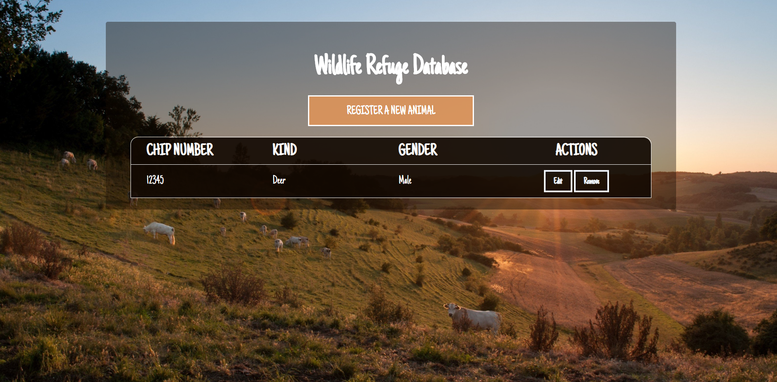

### Create Page

#### Route: **"/create"**

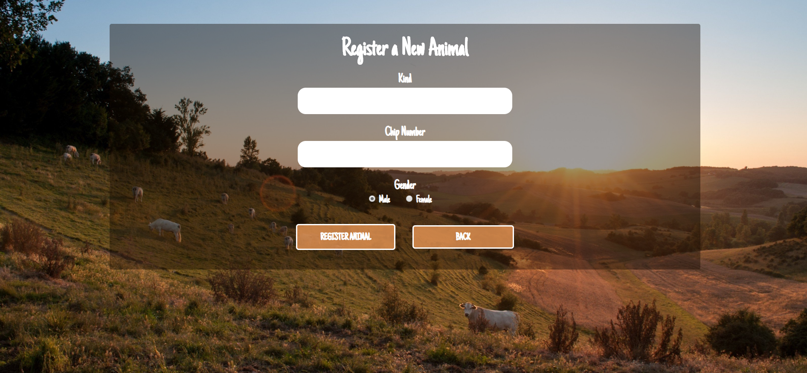

### Edit Page

#### Route: **"/edit/{id}"**

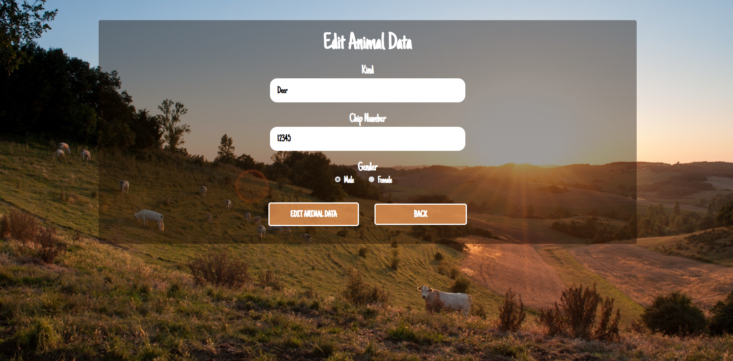

### Delete Page

#### Route: **"/delete/{id}"**

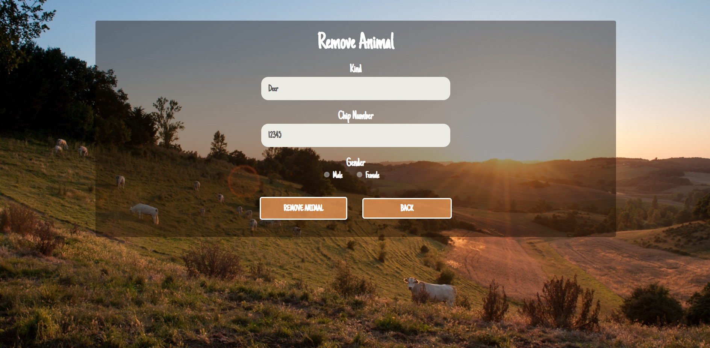

## Problem

As you can see the different pages are on different routes. Most of the routing logic will be given to you in the **Skeleton**, but you should make sure that the application **works properly**.

Implement the "**WildlifeRefuge" app** using only **your technology.**

## Setup

Before you start working, make sure you **download all the dependencies** (packages) required for your technology and **set up** the **databases**! Below are instructions on how to do this:

### PHP and Symfony

1. Make sure you've started your **MySQL server** (either from **XAMPP** or standalone)
2. Open a **Terminal in PHPStorm** or **shell** / **command prompt** / **PowerShell** window in the **root directory**: [Shift] + [Right click] 🡺 [Open command window here]
3. Enter the "composer install" command to restore its **Composer dependencies**   
   (described in composer.json)
4. Enter the "php bin/console doctrine:database:create --if-not-exists" command
5. Done!

### JavaScript and Node.js

1. Go into the **root directory** of the project (where the index.js file is)
2. Open a **shell** / **command prompt** / **PowerShell** window in the **root directory**: [Shift] + [Right click] 🡺 [Open command window here]
3. Enter the “npm install” command to restore its **Node.js dependencies** (described in package.json)
4. Type **node index.js** to start the server
5. Done!

### C# and ASP.NET

The C# project will automatically resolve its **NuGet dependencies** (described in packages.config) using the NuGet package restore when the project is built.

### Java and Spring MVC

When you import your project, you should **uncheck "**Create IntelliJ IDEA modules for aggregator projects (with 'pom' packaging)**"**:

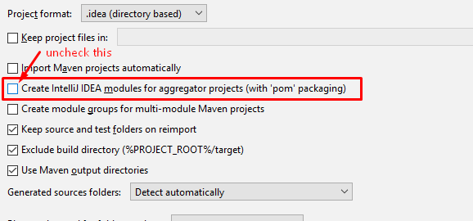

This project is **set up to use Java jdk 1.8.** If your version is different, you can change it in **Maven dependencies** like this:

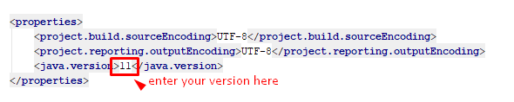

The Java project will automatically resolve its **Maven dependencies** (described in pom.xml) when the project is built.